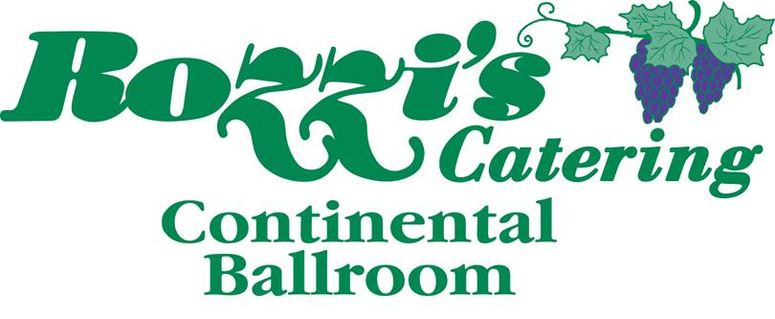
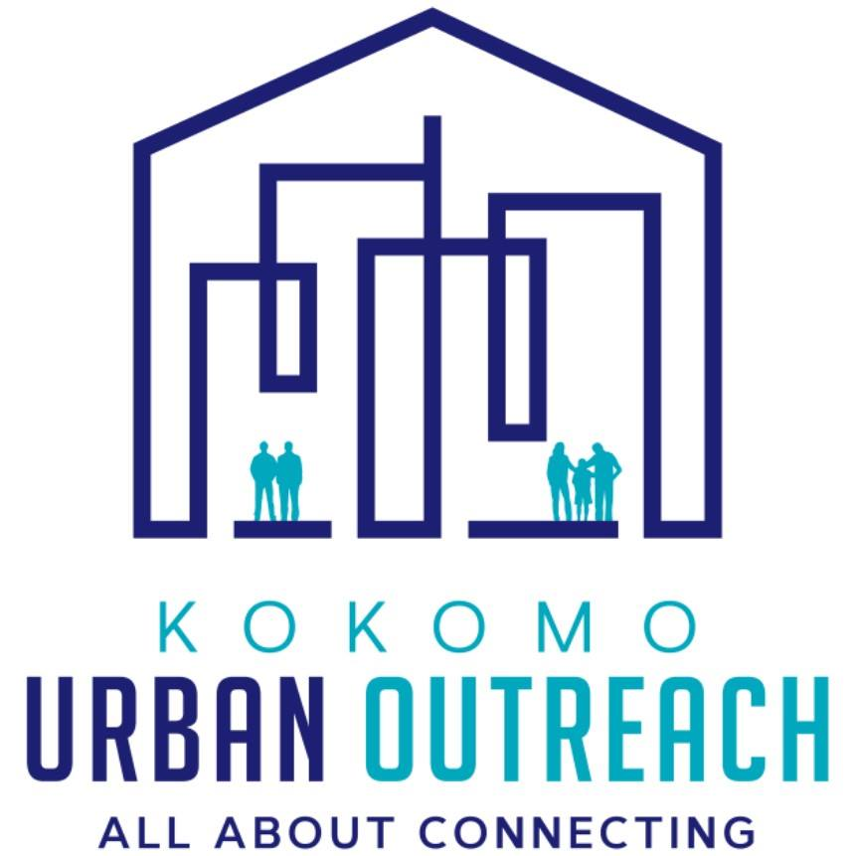

Every day in Howard County families wake up to empty bowls- no cereal, no breakfast.
You have an opportunity to help change this. On Friday March 10th, 2017 Kokomo Urban Outreach (KUO) and Rozzi’s catering will present the 3rd Annual Empty Bowl- a fundraiser to fight hunger in Howard County.
The Empty bowl is an event where supporters enjoy a simple meal of soup and bread. After the lunch they are invited to take a ceramic bowl decorated by children in the community. The bowl is a reminder that there are families in our community that struggle with hunger every day.
So how can you help? Donations are being sought to help pay for the clay bowls and other supplies needed to decorate the bowls.
We hope you will consider supporting this important event. And we hope you will join us at Rozzi’s Catering at the Continental Ballroom on Friday March 10th between 11am and 1pm or 4 and 7pm as we gather at the third Empty Bowl event.

God Bless you,

_________________________________
Jeff Newton, Executive Director

Kokomo Empty Bowls Project -- March 10, 2017
“Fighting hunger one empty bowl at a time”
Sponsorship Opportunities
In-Kind Sponsorship
- Food and beverage donations will be recognized in the event program, social media platforms pre- and post- event, and on the Kokomo Empty Bowls website
- Quarter page program ad
- Company name will be recognized on signage at the event in the food and beverage area
- Donation of other in-kind Items will be promoted on an individual basis
Golden Ladle- $1000
- Prominent recognition as Golden Ladle sponsor in event program and on social media platforms pre- and post- event
- Placement of logo on event signage, t-shirts, table tents and marketing materials (can supply own banner to be hung at event)
- Company name, logo and link to your website on the Kokomo Empty Bowls website as well as being mentioned on the radio
- Eight VIP tickets to the event, allowing early entry(10:30am or 3:30pm) to ensure the best selection among over 700 bowls decorated by children in the community
Silver Spoon- $500
- Recognition as Silver Spoon sponsor in event program and on social media platforms pre- and post- event
- Logo on event t-shirts, table tents, and marketing materials
- Half page program ad
- Four VIP tickets to the event, allowing early entry(10:30am or 3:30pm) to ensure the best selection among over 700 bowls decorated by children in the community
Bronze Bowl- $250
- Recognition as Bronze Bowl sponsor in the event program and on social media platforms pre- and post- event
- Company name on table tents and marketing materials
- Company name on Kokomo Empty Bowls website
- Quarter page program ad
- Two VIP tickets to the event, allowing early entry (10:30am or 3:30pm) to ensure the best selection among over 700 bowls decorated by children in the community
Copper Cup- $100
- Recognition as Copper Cup sponsor in event program and on social media platforms pre- and post- event
- Company name on the Kokomo Empty Bowls website
- Business card size program ad
- Complimentary VIP ticket to the event allowing early entry (10:30 am or 3:30pm) to ensure the best selection among over 700 bowls decorated by children in the community
Kokomo Empty Bowls Project -- March 10, 2017
Empty bowls is an international grassroots effort to fight hunger. The basic premise is simple: Children and others work in the community to create handcrafted bowls. Guests are invited to a simple meal of soup and bread. In exchange for a cash donation, guests are asked to keep a bowl as a reminder of all the empty bowls in the world. The money raised will go to Kokomo Urban Outreach to help food insecure families.
You can learn more about The Empty Bowl Project on our social media sites or send us an email!
Facebook: The Empty Bowl-Kokomo Website: www.emptybowlskokomo.weebly.com
Email: emptybowlskokomo@gmail.com
--------------------------------------------------------------------------------------------------------------------------------------------------
How to Become a Sponsor
If you are interested in becoming a sponsor for the Empty Bowls project in Kokomo, please fill out the form below. If you have further questions feel free to contact Kokomo Urban Outreach at 765-457-1983, Rozzi’s Catering at 765-459-9218 or Kelsey Griffin at kgriffin@rozziscatering.com / 765-860-3470. Make checks payable to Kokomo Urban Outreach and mail to 1701 S. Locke Street Kokomo, Indiana 46902.
Sponsorship Information
By supporting the Kokomo Empty Bowls project you are helping in the fight against hunger in our community. Your sponsorship supports hunger relief and helps to provide assistance to food insecure families in your community. The Empty Bowls event brings together children, restaurants, businesses and community members for one common cause which is to raise awareness of food insecurity and all of the empty bowls around us.
Name: _______________________________ Business: _____________________________
Phone: ______________________________ Address: ______________________________
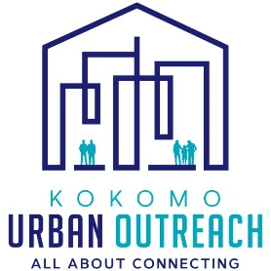
Sponsor level donation: ______________________________________________________________
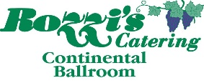
Cash: _____ Check: _____ Credit card: _____
PayPal donations are also accepted at kokomourbanoutreach.org
To ensure that your company’s name is listed on the event program and other promotional items please submit your sponsorship information by February 27, 2017.

